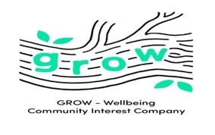 GROW WELLBEING Registration form

Event/Date |  | Forest School
Venue

Child’s Full Name | Date Of Birth (mm/dd/yyyy) | Medical Information | Dietary needs

Home - Street Address
Address line 2
Town/City
Postcode
Parent/ Carer name
Parent/carer Mobile Phone number
Parent/carer email

Photo consent

Please confirm permission for you and your child/children’s photos and videos to be used for website, social media, advertising and local press. | YES/ NO

Medical permissions

In the event that medication or medical treatment may need to be administered, please give permission as follows:

Permission for staff to seek emergency treatment and advice from a medical practitioner | YES/ NO
Permission, in the event of an emergency, to take affected attendee to see a GP/A&E/ hospital | YES/ NO
Parental Consent
Have you read and understood GROW-Wellbeing 's Terms and Conditions? |  | YES/ NO
Please sign to confirm that you have parental / guardian responsibility of the child named on this registration form and that you confirm that you consent to their full participation in the forest holiday club.
Name:  Date: | Signature:

