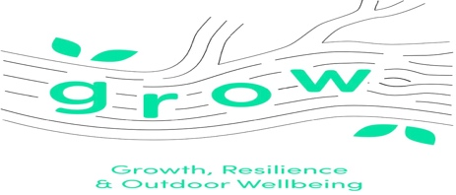 | Site Risk Assessment and Risk Benefit
Location  Forest School area to rear of School | EMERGENCY CONTACTS  HOSPITALS  A&E | Date
 |  | Group
 |  | Possible Visitors to site
Location: |  | Activity Leaders | Duane Chong  Tony Mathewson

Hazard |  |  |  |  | Persons affected |  |  | Effect Of hazard |  |  |  |  | Severity | Likelihood |  | Total Risk | Existing and additional Control Measures  (Where appropriate) |  |  |  |  | Risk Benefit | Who is responsible | Severity | Likelihood | Total Risk
Trip hazards
Nettles, prickly plants
Pond

Overhang branches

Name of Assessor |  |  |  |  |  |  |  |  |  | Signature of Assessor |  |  |  |  |  |  |  |  | Date
RISK ASSESSMENT MATRIX
RISK |  |  |  |  |  |  |  |  |  |  |  | SEVERITY |  |  |  |  |  |  |  | LIKELIHOOD
Severity | 5 | 5 |  | 10 |  | 15 | 20 |  | 25 |  |  | 5 |  |  | Multiple fatality |  |  |  |  | 5 | Almost Certain
 | 4 | 4 |  | 8 |  | 12 | 16 |  | 20 |  |  | 4 |  |  | Fatality |  |  |  |  | 4 | Probable
 | 3 | 3 |  | 6 |  | 9 | 12 |  | 15 |  |  | 3 |  |  | Major injury |  |  |  |  | 3 | Possible
 | 2 | 2 |  | 4 |  | 6 | 8 |  | 10 |  |  | 2 |  |  | Minor injury |  |  |  |  | 2 | Remote
 | 1 | 1 |  | 2 |  | 3 | 4 |  | 5 |  |  | 1 |  |  | Negligible impact |  |  |  |  | 1 | Improbable
 |  |  | 1 | 2 |  | 3 | 4 |  | 5
 |  |  | Likelihood

The aim is to reduce the risk by prevention or control measures so far as is reasonably practicable.

Explanatory Note:

Risk |  | Likelihood
16-25 | Very high (Do not proceed without authorisation from the Directorate) | Almost certain | Self explanatory
12-15 | High | Probable | More likely than not to occur
6-10 | Medium | Possible | Has the potential to occur
1-5 | Low | Remote | Unlikely to occur
 |  | Improbable | Occurrence is extremely unlikely
Severity
Multi fatality | Self explanatory
Fatality | Self explanatory
Major injury | Reportable incident under RIDDOR such as fracture of bones, dislocation, amputation, occupational diseases (e.g. asthma, dermatitis), loss of sight.
Minor injury | First aid administered. This would include minor, cuts, bruising, abrasions and strains or sprains of ligaments, tendons, muscles
Negligible impact | Self explanatory

